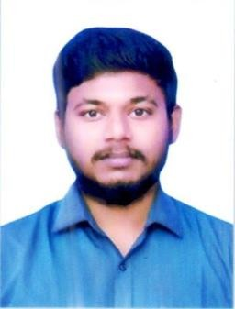RESUME

R.RAGUL

S/o Raj

D.No. Madha Kovil Street, Bommidi Vill & Post Pappireddipatty Tk Dharmapuri Dist-635301

 [ragulraj1497@gmail.com](mailto:ragulraj1497@gmail.com) 9952372515



**Career Objectives:**

Seeking a challenging and innovative position to use of the knowledge acquired so far, for the benefit of the country in general and my employer in particular and in the process enhance my knowledge and skills.

# Educational Qualification:

* **Diploma In Automobile Engineering, DOTE**
* Sreenivasa Polytechnic College, Bommidi
* 2016
* 70%

# School Secondary Leaving Certificate, TN State Board

* Government Higher Secondary School, Bommidi
* 2012
* 60%

# Experience:

* Over All 4years experience in **ASHOK Leyland** production 2years assembly, 2years dealership.
* 1year senior technician in **KRISHNA Motors**, Hosur
* 1year PDI in-charge in dealership **KRISHNA Motors**, Hosur
* Currently I am working in Engine Assembly **PSA AVTEC Pvt Ltd**, Hosur

## Additional Job:

* Spot welding
* Spray Painting
* I know Right and Left side Vehicle Driving LCV

# Computer Skills:

* Basic Computer Knowledge
* MS Office

## Technical Skills

* Vehicle Implement for Ashok Leyland, Hosur

# Area of Interest:

* Production
* Maintenance

# Accomplishments:

* Highly motivate and energetic.
* Striving for Excellence with innovative intension.
* Working in all circumstance with necessary planning.
* Systemizing manual work.

 **Hobbies:**

* Writing and Sketching
* Photography & Designing
* Playing Games

# Personal Details:

Name : Ragul R

Father’s Name : Mr.Raj

Date of Birth : 11/04/1997

Gender : Male

Marital Status : Unmarried

Nationality : Indian

Religion : Hindu Language Known : Tamil, English

Passport number : V3875116

Driving License No :TN29T20160000025

## Declaration:

I do hereby declare that the above particulars given by me are true and correct to the best of my knowledge.

Date: Yours Faithfully,

Place: **(RAGUL.R)**